**Project proposal**

**TicketBuzz: local bus seat reservation app**

Name : M.H.I.D.PREMARATHNE

Registration Number : EN 91397

Index Number : 18/ENG/081

Course Code : CO3302

Field of Specialization: Computer Engineering

**Table of Contents**

**Executive Summary ....................................................................................................1**

**Background ..................................................................................................................2**

**Objectives......................................................................................................................3**

**Future Developments .........................................................................................4**

**Key Features .......................................................................................................4**

**Milestones .....................................................................................................................5**

**Methodology .................................................................................................................6**

**Case Study ......................................................................................................6**

**Developing application……...........................................................................6**

**Timeline .........................................................................................................................7**

**Cost Analysis .................................................................................................................8**

**Risk ...............................................................................................................................10**

**Appendix .......................................................................................................................11**

**References ......................................................................................................11**

**Executive Summary**

Lately in Sri Lanka all the common systems are getting online and usable through a smart device. From booking an airplane ticket to ordering daily essentials is now only a fingertip away. Most of the service can be accessed by anyone with a mobile phone and an internet connection. But when considering public transportation in our country there is no proper way to connect to bus services to book a ride or to check the location of buses. So, this proposal is to design a ticketing system that can be accessed through a mobile device. So that lot of time will be saved.

**Background**

Public transportation has become such an integral part of the present world. Majority of the citizen use public transportation in daily life. In Sri Lanka most of main companies and factories situated in western province, so people who live outside of these areas use long trip buses to get to their workplaces. Most of the people who visit their workplace daily, use public transportation to avoid traffic and the tiredness of driving by themselves. Because of high demand, public transportation has become an essential and very busy service. Usually in the morning and the around school ending and the office ending time is the busiest time for the public transportation services. Lot of people use long trip buses in this time period.

Most of the people buy bus tickets after they get on to the bus. There are several services that provide booking services through phone calls. But there are a lot of disadvantages to these services. A main disadvantage is that the person has to travel only in the specific bus given by the service. So they have to wait for the bus. Another one is person has to go to the starting location or wait in the road for the bus. Even if the bus got late or regardless of how many buses that person missing that taking the same route. So when we have to be on time it is difficult to book a bus seat from this services. Especially for workers, they have to be on time. So most people do not use these systems.

In sri lanka there is no running app for highway buses and long distance bus seat reservation. There is a web page for highway bus seat reservation but it seem like have a bug, no matter where ever user selected it only shows “all are booked.”

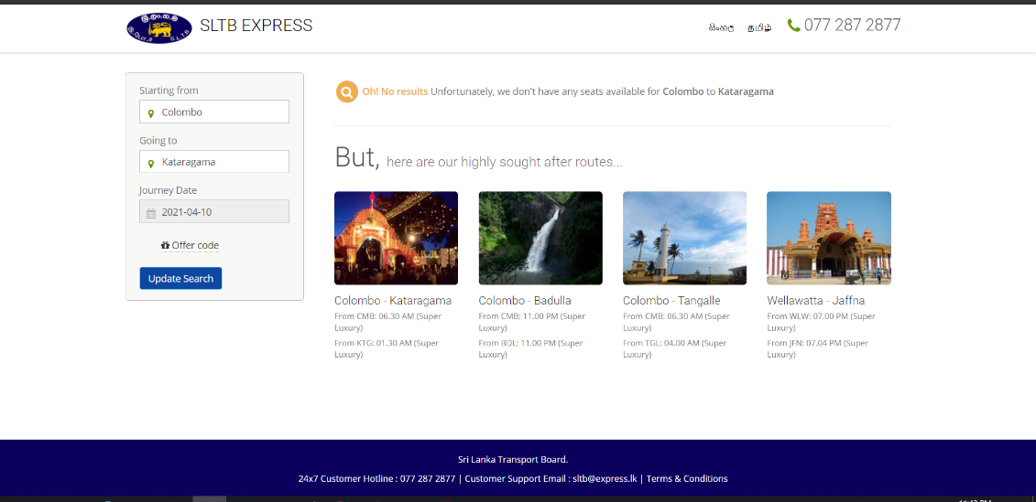

Image 1:bugs in the existing system

So in Sri Lanka there is no working online platform to book tickets for a bus.

**Objectives**

The main purpose of the project Buzz , bus ticket booking system is to use mobile technology for the bus ticket booking system. Sri Lankan Travelling Board has a ticket booking system through their official website but most of the researches show that using an app is way more effective and engaging than a website. So the objective of this project is to engage more people on an online platform of a public transportation ticket booking.



Image 1: Monthly Usage of App and Mobile Web (Chaffey, 2016)

There are 2 apps in this project. For driver, there is a simple app to where a driver can register giving vehicle type, route number, driver’s name, number of seats available in the vehicle. driver can register by using their phone number. After the registration driver can select his availability, available number of seats. And app shows his ratings and personal details. Second app is the passenger/user app. User can register using their phone number. User can enter the bus route and all the available drivers will be displayed on the map so the passenger can choose a bus they want. After selecting diver can accept or decline their

request according to availability. Passenger also can rate the driver and the ride end of the trip.

**Future developments**

As future development app will support train schedules and location indications. Also can book an e-ticket for the train. In current situation app will only support for luxury and semi luxury services (long distance buses and highway buses). Hope to develop this for short distance buses as well with more advanced ticket issuing system and a payment method.

**Key features**

1. Registration - possible via phone number with verification.
2. Ticket Booking - refers to the feature represented on the screen for entering the address, selection of car type, and set pickup location.
3. Fare Calculator - the customer can check the price for a ride beforehand. This feature is a complex one to implement on the backend side of the system.
4. Driver Tracking - feature to observe the driver’s movement to make updates during or after the journey.
5. Payment - multiple payment variants may be implemented; cashless - in-app payment via credit cards, services like PayPal, or simply in cash.
6. Push Notifications - vital element for informing; keeps passenger up-to-date with trip request status, bus arrival time, driver and bus details, etc.
7. Driver Rating & Review - corresponds to the service evaluation (driver, vehicle, trip, etc.).
8. Travel History - shows details from previous rides and transactions.
9. Customer Support

**Milestones**

1. Case study and information gathering for the system
2. Designing mobile application UI for users.
3. Designing mobile application UI for drivers.
4. Building mobile application using Flutter and Dart language
5. Design and implementation of database and integration of firebase services.
6. Integration testing of the sub systems
7. Connecting the system
8. System Testing

**Methodology**

Following agile principles, functionality delivered should be a thin end-to-end slice and after some consideration the project was built using a Model-View-Controller (MVC) architecture. it is much faster as well as convenient. App testing will be done while the app is being built, and integration testing will be done after the app have been built. Finally, system testing will be completed in order to complete the system.

Following tools will be used throughout the project are as follows,

* Flutter framework
* Firebase services
* Cloud Firestore
* SQLite

As the coding language I use dart language.

**Case Study**

A case study will be conducted to analyze the problem statement and design the system's specific use cases and architecture. At this point, the requirement specification will be completed and documented. During this phase, the project log book will be started. In addition, during this phase, the project's limitations will be identified and analyzed so that they do not affect the final product. During the case study, possible test cases for testing phases will be documented. During this phase, future developments will also be examined.

**Developing application**

This app will be coded by the Flutter framework and Dart programming language, with the design following the Google developer team's BLoC pattern. Dart is a high-level programming language that can be used in conjunction with the flutter framework to create native cross-platform Android and iOS apps. The main reason for using flutter in this case is because of its ease of use and cross-platform capabilities. Driver’s location and type of the vehicle, available number of seats will be provided to the passengers. In the first use, users can create an account, login, and connect to the device. The application will take care of everything for the user after the second time.

**Timeline**

|  |  |  |  |  |  |  |  |  |
| --- | --- | --- | --- | --- | --- | --- | --- | --- |
| **Activity** | **Week** | | | | | | | |
| 1 | 2 | 3 | 4 | 5 | 6 | 7 | 8 |
| Case study and information gathering for the system |  |  |  |  |  |  |  |  |
| Designing mobile application UI for users. |  |  |  |  |  |  |  |  |
| Designing mobile application UI for drivers |  |  |  |  |  |  |  |  |
| Building mobile application using Flutter and Dart language |  |  |  |  |  |  |  |  |
| Design and implementation of database and integration of firebase services |  |  |  |  |  |  |  |  |
| Integration testing of the sub systems |  |  |  |  |  |  |  |  |
| Connecting the system |  |  |  |  |  |  |  |  |
| System Testing |  |  |  |  |  |  |  |  |

**Cost Analysis**

Free versions of software is using to build the app. But when publishing it needs to register in google playstore and apple Appstore. The starting point is the Google Play Developer Console. It is Google’s dedicated dashboard for developers that lets you manage your apps in the Play Store. Google has a one time $25 registration fee which you need to pay before you can upload an app. Google says it encourages higher quality products, i.e. less SPAM. If you don’t like the idea then it helps to look at Apple’s and Microsoft’s policies for their app stores. Apple charges $99 per year. Microsoft charges between $12 and $99 per year, depending on the account type.

Also google maps is used to get the mapping details.

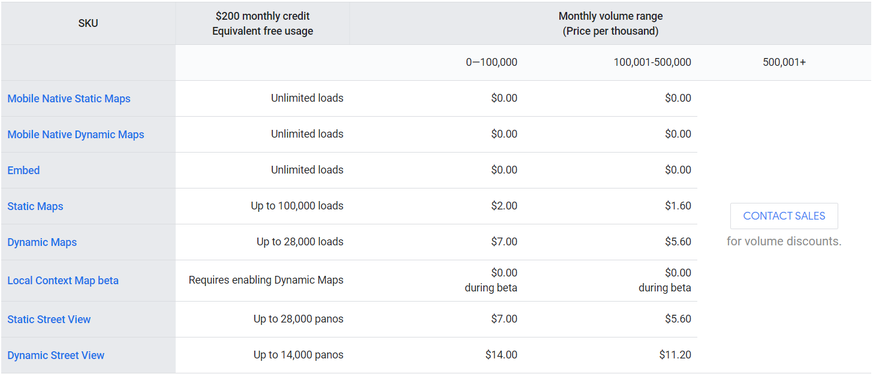

Image 2 : google map costs

Also google cloud services are used to save the user details.

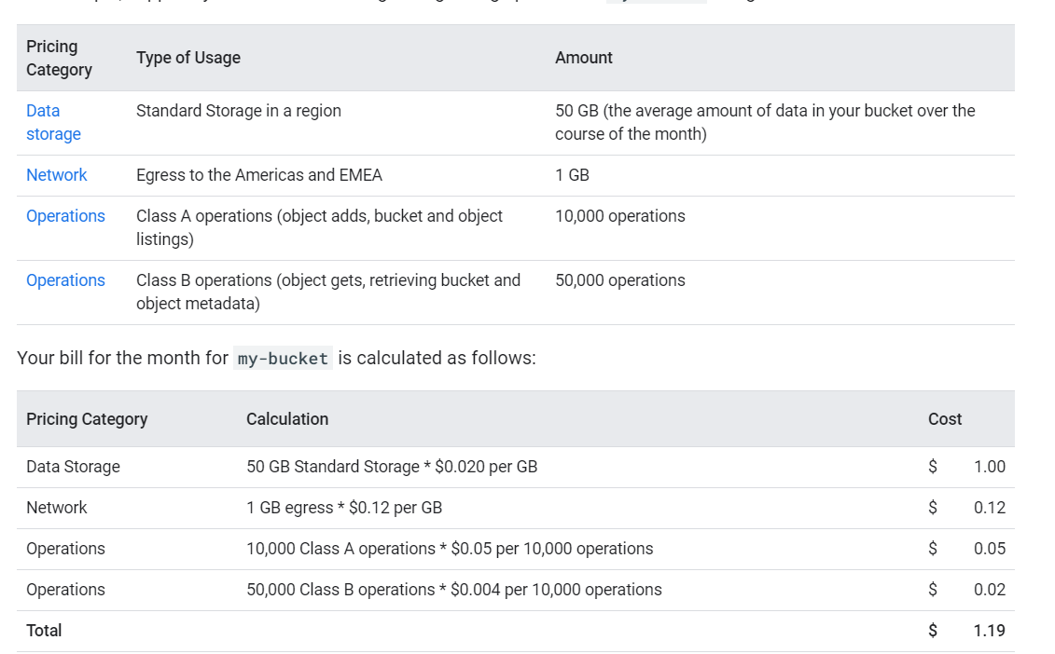

Image 3 :google drive costs

All the services are free for some extend. After the publication all costs will be added.

**Risk**

1. Due to heavy weightage app can be under perform and can cause in lags. Solution for this is using simple maps and simple animations.
2. Dependency failures in flutter. Solution is documentation of each and every package used must be carefully studied in order to avoid the risk of dependency issue. However, if the issue cannot be avoided there are multiple packages available to do a task in flutter.
3. Inability to complete the project in a timely manner.
4. Unresolved bugs in the system.
5. Failure of the system when presenting.

**Appendix**

1. [1]"Pricing Table  |  Google Maps Platform  |  Google Cloud", *Google Cloud*, 2021. [Online]. Available: https://cloud.google.com/maps-platform/pricing/sheet. [Accessed: 28- Mar- 2021].
2. [2]"Publishing your first app in the Play Store: what you need to know", *Android Authority*, 2021. [Online]. Available: https://www.androidauthority.com/publishing-first-app-play-store-need-know-383572/#:~:text=It%20is%20Google's%20dedicated%20dashboard,you%20can%20upload%20an%20app. [Accessed: 28- Mar- 2021].
3. [3]"Cloud Storage pricing  |  Google Cloud", *Google Cloud*, 2021. [Online]. Available: https://cloud.google.com/storage/pricing. [Accessed: 28- Mar- 2021].
4. [4]"Mobile marketing statistics compilation | Smart Insights", *Smart Insights*, 2021. [Online]. Available: https://www.smartinsights.com/mobile-marketing/mobile-marketing-analytics/mobile-marketing-statistics/. [Accessed: 28- Mar- 2021]